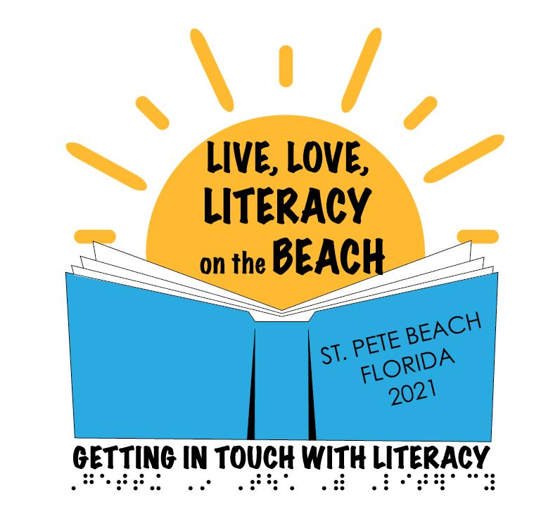

GITWL 2021 Sponsorship Packet
The 2021 Getting in Touch With Literacy Conference, held December 1-4, 2021 at the TradeWinds Island Grand Resort, St. Pete Beach, FL, will draw approximately 350-400 dedicated people from around the world, including researchers, educators and other professionals who promote literacy for children and adults who are visually impaired.
The 2021 conference is the finale event for Getting In Touch With Literacy and we know you won’t want to miss this opportunity to introduce your products and services to experts and key stakeholders in the field, along with parents and other consumers. The conference will provide special vendor events and opportunities for you to meet with highly motivated teachers, family members, consumers, and others with decision-making and purchasing power! Plus, your participation and financial assistance will help support the costs of key speakers, meal functions, conference bags, and other incidentals, keeping registration costs low and participation high.
We anticipate an exciting and well-attended conference. We would like to include your company or organization's name in our list of exhibitors or sponsors, and see your products and/or services displayed at GITWL. We look forward to working closely with your representatives to plan the most productive sponsorship and exhibit hall experience possible.
A special conference rate of $167 per night is available at the TradeWinds Island Grand Resort from November 29 through December 6, 2021. Reservations can be made online at: https://www.tradewindsresort.com/gitwl.

Sponsorships are limited, so sign up soon!

For further information or to coordinate vendor sponsorships, contact the conference organizers:

Liz Anderson eanderson@fimcvi.org
Janie Blome janie.blome@att.net

GITWL Sponsorship Opportunities

BUILD ADDITIONAL NAME RECOGNITION AND ATTENDEE INTEREST WITH THESE EXCELLENT SPONSORSHIP OFFERINGS!

A sponsorship is a proven way to build prestige and stand out from the crowd. Ensure your message reaches beyond the exhibit hall by supporting Getting In Touch With Literacy at one of the following sponsorship levels:

MERMAID SPONSOR: $7500
- Official partial sponsor of a meal function (i.e. full breakfast, poster session lunch, awards brunch, reception, break) with slideshow presentation of featured products during selected function; a value of $4000.
- Opportunity to address attendees during the event.
- Large sign acknowledging MERMAID sponsorship in the room for event being sponsored.
- Extra large vendor space of 3 tables, including electrical and wifi access; a value of $2725.
- Acknowledgment of your sponsorship by conference chairs and presentation of your logo in a slide show at all banquets and keynote sessions.
- Full page color ad inserted on the back inside cover or other prominent location in the 2021 GITWL conference guide; a value of $1000.
- Acknowledgment of MERMAID level of sponsorship in the 2021 GITWL conference guide.
- Your logo and company name printed on the 2021 GITWL conference tote bags, giving you high impact visibility throughout the conference and insertion of approved corporate marketing material literature in bag. Have all attendees carry your message with them; a value of $1750.
- Acknowledgment as MERMAID level sponsor (with logo) on 2021 GITWL conference website and GITWL Facebook page with active link.
- Sponsor ribbons on the badges for all attending company representatives.

SAND CASTLE SPONSORS: $5000
- Official partial sponsor of a continental breakfast with sign acknowledging SAND CASTLE sponsorship during selected function; a value of $2500.
- Large vendor space of 2 tables, including electrical and wifi access; a value of $2125.
- Banner acknowledging sponsorship in exhibit area with name on the banner representing SAND CASTLE level of sponsorship.
- Acknowledgment by conference chairs at morning keynote sessions and opening/closing general sessions.
- Acknowledgment of SAND CASTLE level of sponsorship in 2021 GITWL conference guide.
- Full page ad (with logo) in 2021 GITWL conference guide; a value of $850.
- Your logo and company name printed on the 2021 GITWL conference tote bags, giving you high impact visibility throughout the conference and insertion of approved corporate marketing material literature in bag. Have all attendees carry your message with them; a value of $1750.
- Acknowledgment as SAND CASTLE level sponsor (with logo) on the 2021 GITWL conference website and GITWL Facebook page with active link.
- Sponsor ribbons on the badges for all attending company representatives.

DOLPHIN SPONSORS: $2000
• One free table in the exhibit hall, including electrical and wifi access; a value of $1525 (additional tables available for purchase at regular vendor rate).
• Acknowledgment of DOLPHIN level sponsorship (with logo) in the 2021 GITWL conference guide.
• Half page ad (with logo) in the 2021 GITWL conference guide; a value of $600.
- 2021 GITWL conference bag inserts (brochure or one-page advertisement); a value of $400.
• Acknowledgment as DOLPHIN level sponsor (with logo) on the 2021 GITWL conference website and GITWL Facebook page with active link.
• Sponsor ribbons on the badges for all attending company representatives.

If you would prefer to sponsor a specific item or event or place an ad without an exhibit, please see below for additional opportunities.

A LA CARTE MENU FOR SPONSORSHIPS AND VENDORS

Advertisements in the conference program:
Full page inside front cover; color = $1000
Full page inside back cover; color = $1000
Full page ads = $850
Half page ad = $600
Quarter page ads = $500
Business card/tributes = $300

SPECIAL OPPORTUITY!!!!
The 2021 Florida AER Conference will take place just prior to Getting In Touch With Literacy. Special time will be available for FAER attendees to visit GITWL vendors. Sponsors are invited to advertise in the FAER program book for only $100. This opportunity will allow sponsors to share their information with the rehabilitation professionals, educators, administrators and others attending the FAER conference.

2021 GITWL Conference Bags – your logo prominently displayed on conference bags for all attendees; free conference bag insert - $1750

2021 GITWL Conference Bag Inserts (brochure or one-page advertisement) - $400

Media Sponsors – your logo displayed on warming screens in all concurrent session workshops and pre-conference workshops; helps to defray cost of AV for the conference; $1500

2021 GITWL Program Book/Conference Guide – acknowledgement of your sponsorship to print and braille the conference program book prominently displayed in the program book; free half page ad included - $1000

Meal/Function Sponsorship – (partial support for meal function or break) Your logo displayed prominently on signs throughout the function space. Your company/organization name listed in conference program as meal/function sponsor - $2000 - $4000 (contact janie.blome@att.net for details)

Donations to GITWL 2021 Conference Finale – donors will be recognized in the conference program
St Pete Level = $500
Tampa Level = $250
Florida Level = $100
GITWL 2021 Sponsorship Form

 | Number Ordered | Price Per Unit | Amount Owed
SPONSORSHIP ORDERS
Mermaid Sponsorship |  | $7,500.00
Sand Castle Sponsorship |  | $5,000.00
Dolphin Sponsorship |  | $2,000.00
A LA CARTE MENU ITEMS
Program Advertisement: Full page, inside front cover – color |  | $1000.00
Program Advertisement: Full page, inside back cover – color |  | $1000.00
Program Advertisement: Full page |  | $850.00
Program Advertisement: Half page |  | $600.00
Program Advertisement: Quarter page |  | $500.00
Program Advertisement: Tribute (Business Card Size) |  | $300.00
Special Opportunity: FAER Program Book Ad |  | $100.00
Conference Bag Logo/Bag Insert |  | $1750.00
Conference Bag Inserts |  | $400.00
Media Sponsors |  | $1500.00
Program Book/Conference Guide |  | $1000
Meal/Function |  | TBD
Ads must be provided in print-ready electronic format; 300 dpi RGB JPEGS are preferred. Please email print-ready files to janie.blome@att.net
Total
(US $ Only)

SPONSORSHIP OPPORTUNITIES ARE LIMITED.
SUBMIT YOUR APPLICATION SOON!

Please make checks payable to GITWL and mail to:
GITWL
c/o Sandy Lewis
688 Attitude Ave
Daytona Beach, FL 32124

Please contact eanderson@fimcvi.org for credit card payments.
15th Biennial Getting In Touch With Literacy Conference

December 1 – 4, 2021
TradeWinds Island Grand Resort
5500 Gulf Blvd, St. Pete Beach, FL 33706
Phone: (727) 367-6461 or (800) 360-4016

SPONSORSHIP APPLICATION

______________________________________________________

(please print your organization name)

will support the 15th Biennial GITWL conference, December 1-4, 2021 with a sponsorship/a la carte item(s) in the amount of $_______.

COMPANY NAME: ________________________________________

COMPANY WEBSITE: ______________________________________

MAILING ADDRESS: ______________________________________

CITY: _________________________ STATE: ___

ZIP/POSTAL CODE: _________________

PHONE: ( ) ________________ FAX: ( )______________

Brief description of your agency/organization:

The above information will appear in the conference program and on the GITWL website at gettingintouchwithliteracy.org

Please submit a print ready copy of your company logo at janie.blome@att.net for use on the GITWL website and in the conference program book.

Please provide the information below if you will be exhibiting at the conference:

Names of exhibit representatives
Please print names of all representatives who wish to have GITWL badges and conference programs. Badges will be required to enter the exhibit hall during off hours.

- ________________________________________________________

- ________________________________________________________

- ________________________________________________________

4) ________________________________________________________

The conference program is available in print, braille, and digital download upon request. Please circle choices and indicate number of each:

Print _____ Braille _____ Digital Download _____

All conference materials will also be available to load on your flash drive at the conference registration desk if desired.

GITWL strives to provide the most accessible venues to all conference attendees. Please indicate your desire to have:

Hotel orientation and tactile map _____
Guide dog relief area orientation _____

Exhibitor Information and Preferences

If you chose to exhibit as part of your sponsorship, please indicate your choices so we may consider your wishes while preparing the exhibit hall layout. We will make every effort to accommodate as many preferences as possible, based upon earliest received application. Thank you for your understanding.

REMINDER: Please do not tape, staple, or tack anything
to the walls of the exhibit hall.

Does your display feature a large screen, backdrop, or other frame that would block the view of adjacent GITWL exhibitors?
Yes_____ No_____

Is your display a tabletop display? Yes_____ No_____

If no, how large is your display? Height____ Width_____

Please do not locate our exhibit adjacent to the following exhibitors: _____
__________________________________________________________________________________________________________________________________________

The undersigned organization representative agrees that the above organization will abide by all rules, requirements, restrictions and regulations as set forth in this agreement. Failure to do so will result in forfeiture of all monies paid to GITWL under terms of this agreement.

Signature: __________________________________________________

Title: _______________________________________________________

EMAIL ADDRESS: ______________________________________________

TELEPHONE: __________________________________________________

EXHIBIT GUIDELINES

FAER/GITWL COMBINED EXHIBIT OPPORTUNITY
Exhibitors are invited to attend a special combined exhibit day for attendees of Florida AER and Getting In Touch With Literacy on Wednesday, December 1 from 9:30 am – 4:00 pm. Attendees of the Florida AER conference will include rehabilitation professionals, educators, administrators and others. Participation in the combined exhibit day is included in your GITWL conference exhibit fees.

SCHEDULE FOR EXHBIT SET UP:

Tuesday, November 30, 7:00 pm – 10:00 pm
(for those participating in the combined vendor day)
Wednesday, December 1, 7:00 am – 9:00 am
(for those participating in the combined vendor day)
Wednesday, December 1, 5:00 pm – 7:30 pm
(all other vendors)

SCHEDULE FOR EXHBITS

Wednesday, December 1, 9:30 am – 4:00 pm
Combined FAER/GITWL Exhibit Day
Wednesday, December 1, 8:00 pm – 10:00 pm
Welcome Reception and Exhibits
Thursday, December 2, 9:30 am – 5:00 pm
Friday, December 3, 9:30 am – 4:00 pm

EXHIBIT POLICY
Any merchandise for sale at the conference must be available for purchase/order by all conference attendees. GITWL reserves the right to refuse use of space to any exhibitor whose product or program, in the sole opinion of GITWL, is not in keeping with the general character of the conference. GITWL reserves the right to require any exhibitor to remove any exhibit or any part thereof, which, in the sole judgment of GITWL, is misleading, deceptive, in poor taste, or not in keeping with the general character of the conference.

DISMANATLING OF EXHIBITS:

- Exhibits may be dismantled on Friday, December 3, after 4:00 pm or on Saturday, December 4, between 8:00 am and 12:00 pm.
- All equipment, crates, and other materials must be removed. Trash must be bagged and/or put into garbage cans.

Exhibitors themselves may take charge of activities that do not require hotel staff labor, such as handling, placing, setting out and dismantling of exhibit merchandise.

ACTIVITY OUTSIDE OF THE EXHIBIT HALL: No exhibit displays are allowed outside of the exhibit hall. Any vendor event not held in the exhibit hall must take place outside of designated exhibit hall hours. This includes training, social and hospitality events, focus groups and market research. Activities may not be in conflict with scheduled GITWL events including showcase and concurrent sessions.

EXHIBITOR STAFF: At least one attendant should staff each exhibit space during all public Exhibit Hall hours. For proper identification of exhibitor personnel, a badge will be issued for each representative listed on this application and agreement form. GITWL reserves the right to limit the quantity of badges issued and to recall badges used by unauthorized persons.

ADVANCE SHIPMENT OF EXHIBITS: Items for exhibit may be shipped to the hotel no more than seven (7) days in advance of the event. In order to help expedite the timely delivery and return of packages, all boxes must be labeled with name of the group’s recipient (NOT the Hotel Sales or Service Manager), group name, and the date of the program. A sample label is shown below:

SAMPLE SHIPPING LABEL
HOLD for the (Client Name) and/or (Convention Service Manager)
Getting In Touch With Literacy Conference
December 1, 2021
PACKAGE #___ of ___
c/o TradeWinds Island Grand
5600 Gulf Blvd
St Pete Beach, FL 33706

HANDLING FEES
All package handling fees are the responsibility of the exhibitor. Fees may be charged to your room or paid by credit card or cash. A current fee schedule will be supplied by the assigned TradeWinds convention services manager. The maximum weight for any package to be stored is 100 pounds.

A ten (10) day advance notice is required for all pallet shipments. In addition, pallet shipments must be delivered no more than two (2) days prior to the event.

RETURN SHIPMENTS
Exhibitors are responsible for making arrangements to ship their materials out of the hotel as needed.

LIABILITY: Exhibitor agrees that neither he/she nor his/her employees shall efface, mar, or otherwise damage the exhibit premises. Nothing shall be pasted on, tacked, nailed, screwed, or otherwise attached to columns, walls, or furniture. The exhibitor assumes entire responsibility and liability for losses, damages, and claims arising out of the exhibitor’s and his/her representatives’ actions on the hotel premises.

The exhibitor hereby agrees to protect, indemnify, defend, save, and hold harmless GITWL and the TradeWinds Island Grand and hold their employees, management company, owner(s), respective agents, and servants harmless against all claims, losses, and damages to persons or property, governmental charges or fines, and attorney’s fees arising out of or caused by exhibitor’s installation, removal, maintenance, occupancy, or use of the exhibition premises or part thereof, excluding any such liability caused by the sole negligence of the hotel, its employees and agents. Exhibitors must comply with all local fire and safety regulations and must exercise all care to avoid hazardous condition of any kind in the display area.

GITWL 2021 EXHIBIT RIGHTS: GITWL reserves the right to arrange and rearrange the floor plan or relocate space assignments for the betterment of the combined exhibitors and/or because of extenuating circumstances.

INSURANCE: All exhibitors have the sole responsibility for providing insurance coverage at their own expense for business loss/interruption, property loss and/or damage, and liability for personal injury and/or exhibitor’s property.

CANCELLATION OF CONFERENCE: Should the GITWL Biennial Conference be prevented or postponed by any such event or emergency as an act of God, declaration of war by the President, destruction of exhibit premises, strikes, public disturbance, or the like, the exhibitor expressly agrees that GITWL may retain as much of the monies paid for rental of exhibit space as may be necessary to cover expenses incurred up to the time of emergency or disruptive event.

REFUND AND CANCELLATION POLICY: Notice of cancellation must be made in writing to GITWL Exhibits Chair. GITWL will retain 50% of the cost of the booth rental for cancellations up to ten (10) days prior to the conference. All cancellations after that point will result in loss of the full cost.

VIOLATIONS/INFRACTIONS OF THE RULES AND REGULATIONS: Any exhibitor, or his/her employee’s/agent’s violation or infractions of any of the rules and regulations stipulated in this agreement shall annul the exhibitor’s right to occupy exhibit space, and such exhibitor will forfeit the monies that have been paid to use such space.

For GITWL Use Only
Date Application Received:
Date Payment Received:
Space Assigned:

