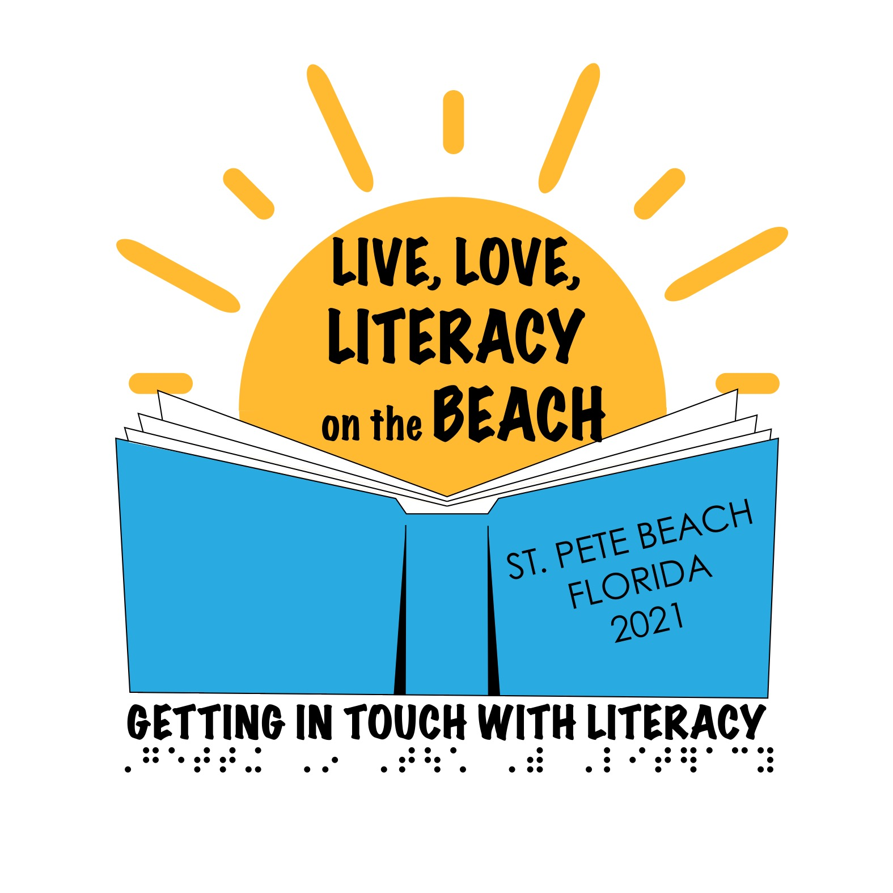
Getting in Touch With Literacy | December 1-4, 2021  St. Pete Beach, Florida

CALL FOR PROPOSALS
Proposals related to all areas of literacy for individuals with visual impairments are now being accepted for presentations at the Fifteenth Biennial Getting In Touch with Literacy Conference. Proposals will be considered that focus on development and use of literacy skills at all age and ability levels and other relevant issues for this special topic conference.
In order to give as many presenters as possible the opportunity to present at this final conference, proposals must be limited to a total of two workshops and one poster session per person. This includes presentations as either lead presenter or as a co-presenter.
The Getting In Touch with Literacy conference is a conference that includes underlying respect for literacy at all ages and ability levels. Presentations are encouraged on topics related to infants and toddlers, school aged students, and adults. Professionals addressing literacy skills in rehabilitation settings are encouraged to submit proposals.
While we expect the conference to proceed as planned, we know there are still valid concerns regarding COVID 19. We continue to monitor conditions and will make any announcements regarding rescheduling the conference no later than July 31, 2021.
To submit your proposal, please complete the information below and return this form, along with a full description of the presentation, to Cay Holbrook, co-chair of GITWL Program Committee (cay.holbrook@ubc.ca) by March 31, 2021. The file name and the subject line of the email should be in this manner: Proposal GITWL 2021 – Last Name (Proposal GITWL 2021 Smith).
Program decisions will be made and presenters will be contacted by April 15, 2021.

Include the following information in your presentation proposal
Name of Lead Presenter:
Affiliation:
Address:
Phone number:
Email:
Co-presenters (name, affiliation, email):

Title of Presentation (as it should appear in the Conference Program):

Type of presentation (all presentations are scheduled for 1 hour):
☐ Lecture
☐ Panel
☐ Workshop (interactive)
☐ Poster
Target audience:

Brief program description (as it should appear in the program and pre-conference advertisements - Limit of 50 words)

Include a one- to two-page full description of your presentation listing three objectives for the participants (this will be used for CEU credits)

Each room will be equipped with a projector and screen. Access to external speakers will be available if requested ahead of time. Presenters are responsible for bringing a laptop or any other necessary equipment.
Speakers must register for this conference. Conference registration information will be available by April 15, 2021. Please check the conference website at www.gettingintouchwithliteracy.org for information regarding registration and hotel reservations.

