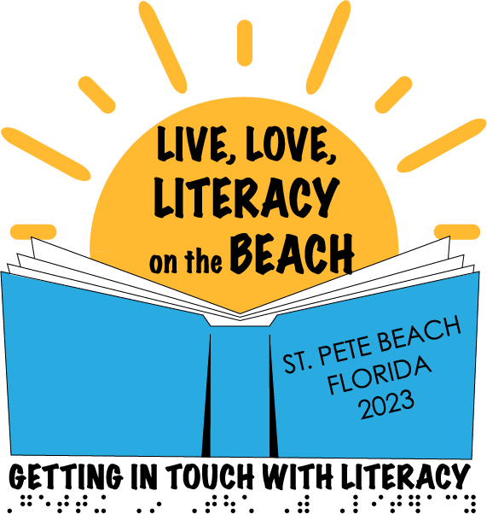
November 29 – December 2, 2023
St. Peter Beach, Florida

Getting In Touch With Literacy 2023
CALL FOR PROPOSALS

Proposals related to all areas of literacy for individuals with visual impairments are now being accepted for presentations at the Fifteenth Biennial Getting In Touch With Literacy Conference. Proposals that focus on the development and use of literacy skills at all ages, ability levels, and in all media, will be considered for acceptance at this premiere topical conference.
In order to give as many presenters as possible the opportunity to present at this final conference, proposals must be limited to a total of two workshops and one poster session per person. This includes presentations as either lead presenter or as a co-presenter.
The Getting In Touch With Literacy conference is a conference that includes underlying respect for literacy at all ages and ability levels. Presentations are encouraged on topics related to infants and toddlers, school aged students, and adults. Professionals addressing literacy skills in rehabilitation settings are encouraged to submit proposals.

To submit your proposal, please complete the information below and return this form, along with a full description of the presentation, to Cay Holbrook, co-chair of GITWL Program Committee (cay.holbrook@ubc.ca) by February 3, 2023. Program decisions will be finalized by late February and decisions will be communicated to submitters in early March.

NOTE: ALL PRESENTERS MUST REGISTER FOR THE CONFERENCE. PRESENTERS ARE RESPONSIBLE FOR THEIR OWN TRAVEL AND ACCOMODATIONS.

Name of Lead Presenter:
Affiliation:
Address:
Phone number:
Email:
Co-presenters’ Names, Titles, Emails and Affiliation (if applicable):
NOTE: All presenters must be listed here to be included in the conference program. Write names, titles, and affiliations exactly as you want them to appear in the program.

Title of Presentation (as it should appear in the Conference Program):

Brief program description (as it should appear in the program and pre-conference advertisements - Limit of 50 words):

Type of presentation (all presentations are scheduled for 1 hour):
☐ Lecture
☐ Panel
☐ Workshop (interactive)
☐ Poster

Please provide a one-page description of your proposed presentation. Information shared might include the following:
- Overall purpose and relevance to literacy
- Type of information being shared (i.e. research, practice oriented, medical).
- Targeted age group (early childhood, elementary, high school, adult, etc.) and population to which information best applies (students/adults with low vision, gifted students, struggling braille readers, students with multiple disabilities, etc.)
- Target audience (teachers of students with visual impairments, rehabilitation teachers, low vision therapists, transcribers, parents, students, or others)

List three learning objectives for the participants (this will be used for CEU credits):

AV Equipment
All rooms will be equipped with the following equipment:
- Speaker's table
- LCD projector
- Screen
- Speaker's podium
If you need the following items, please come prepared with your own equipment:
- Laptop computer
- External speakers
- Adaptors for your equipment
If you have additional AV needs, please specify your needs below. Please note that not all AV equipment requested will be available and there may be an additional charge to the presenter for unique requests, including wifi access.

All speakers must register for the conference and secure their own travel and hotel accommodations. Please check the conference website at www.gettingintouchwithliteracy.org for information regarding registration and hotel reservations.

